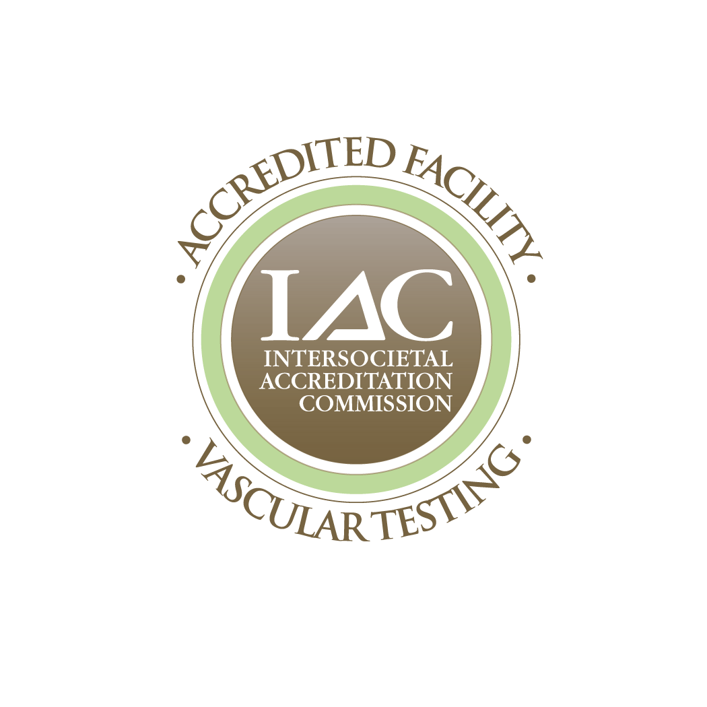
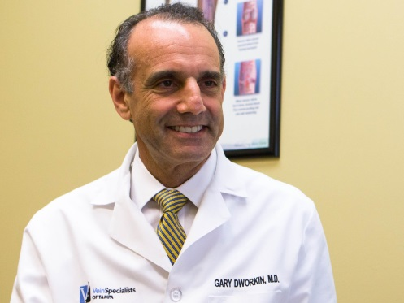

April 2018
Better or Cheaper?
For over 60 years, the treatment of venous thromboembolism (DVT or PE) relied on a combination of heparin and warfarin therapy. Inherent in this method of treatment was the difficulty in managing optimal and safe levels of anticoagulation with warfarin, a drug that has numerous medication and food interactions, and a long onset of action. In addition, drug efficacy was dependent on measurement of blood tests that required regular venipuncture. Finally, numerous studies demonstrated that even with careful warfarin management in a clinic, patients achieve “periods in the therapeutic range” only 60% of the time. This drops to 40-50% in less developed countries.
With the arrival of the newer, more specifically targeted anticoagulant drugs and now 7 years of their clinical use, cost/benefit issues have become hugely important.
It appears these newer drugs are at least as safe as and probably safer than warfarin. They work within 4-6 hours and are as effective as warfarin with periods in the therapeutic range far greater than 60% of the time.
So, why aren’t more of our patients taking these drugs? While there are reasons not to prescribe these new oral anticoagulants (prosthetic valve history, renal insufficiency) I find the biggest issue is price of the medication itself. Many patients tell me their insurance plans make it costly and/or prohibitive for them to be on these medications.

2835 W. De Leon St., #102
Tampa, Florida 33609
(T) : 813-374-9002
(F) : 813-374-9093
www.tampaveinspecialists.com
Gary H. Dworkin, M.D., RPVI
Board Certified in Cardiovascular and
Thoracic Surgery
Registered Physician in Vascular
Interpretation - RPVI

Specializing in the Treatment of:
• Venous Disease
• Varicose Veins
• Reticular Veins
• Spider Veins

We Offer All Accepted Modern Modalities:
• Endovenous Vein Obliteration
• Ultrasound Guided Sclerotherapy
• Compression Sclerotherapy
• Ambulatory Phlebectomy
• Microsclerotherapy
• Laser Treatment

The Convenience You Deserve:
• Bilingual Staff - Se Habla Español
• All Major Credit Cards Accepted
• Large Stock of Medical Grade
Support Stockings & Hosiery
• A Friendly and Supportive
Staff in a Relaxed Setting
• Diagnostic Ultrasound
• Medicare and most insurance accepted

• Financing Options

Hoping to understand this better, I came across 4 recent analyses of cost vs. benefit for patients receiving these new oral anticoagulants for treatment of DVT or PE and for those on chronic treatment as secondary prevention of venous thromboembolism.

The four studies are predictive models based on both clinical and administrative data (Markov models) and often include resource utilization estimates based on what was quoted in other prospective clinical studies; for example frequency of INR testing and its costs over a year. In other words, these studies are not prospective and do not gather data as it is generated in a clinical setting but rely on probabilities based on data found within other studies. Secondly, many of these studies have been done in other countries (UK, Portugal, Turkey) where the stated cost (in US dollars) of all medications including the new anticoagulants are a fraction of what they cost in the US. Finally, and somewhat astoundingly, these published papers were authored by employees of pharmaceutical companies as well as physicians who were paid consultants. Not surprisingly, all four studies stated that the total costs when using the new drugs were equal or cheaper to the total costs incurred over the same time period for the warfarin regimens. So, what to believe?
What I can say is that we do not yet have any good US data to support that the use of the new oral anticoagulant agents is cheaper short term or long term than the standard therapy of heparin followed by warfarin when including the necessary blood tests and costs of managing complications of either drug. It is unusual that there is not yet a US authored prospective cost comparison study out there. Perhaps it’s because a positive study is impossible.
In any event, these new anticoagulants are good drugs and I have been surprised how safe they appear to be in my own patients. If the pharmaceutical companies would only reduce prices a bit, I think a whole lot more of these medications would be prescribed.

It continues to be an honor to help take care of your patients.

Gary H. Dworkin, M.D., RPVI

